Deciphering Music DNA

Ethan Holder

Have you heard that computing was essential for biological scientists to decipher human DNA?

This interdisciplinary research applies computing to decipher the very DNA of music!

Come learn more about it at my poster session!

You can see our proof of concept live here:

<http://mickey.cs.vt.edu/>



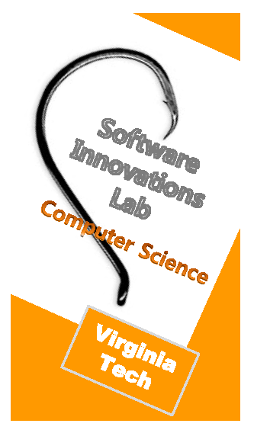 

Deciphering Music DNA

Ethan Holder

Have you heard that computing was essential for biological scientists to decipher human DNA?

This interdisciplinary research applies computing to decipher the very DNA of music!

Come learn more about it at my poster session!

You can see our proof of concept live here:

<http://mickey.cs.vt.edu/>



 